Chapter 1

Section 1
The effectiveness of data communication is based on three functionalities. Delivery, Timeliness and Accuracy. Delivery – the system must deliver data to the correct destination. Timeliness – must be delivered in a timely matter. Accuracy – it must be delivered correctly.

A network is a set of nodes connected by media links. There are three criteria for data communication, Performance, Reliability, and security. Performance is measured in transit time and response time. Reliability of network includes the accuracy of the delivery, failure frequency and recovery time. Security is protecting data.

Data Flow:

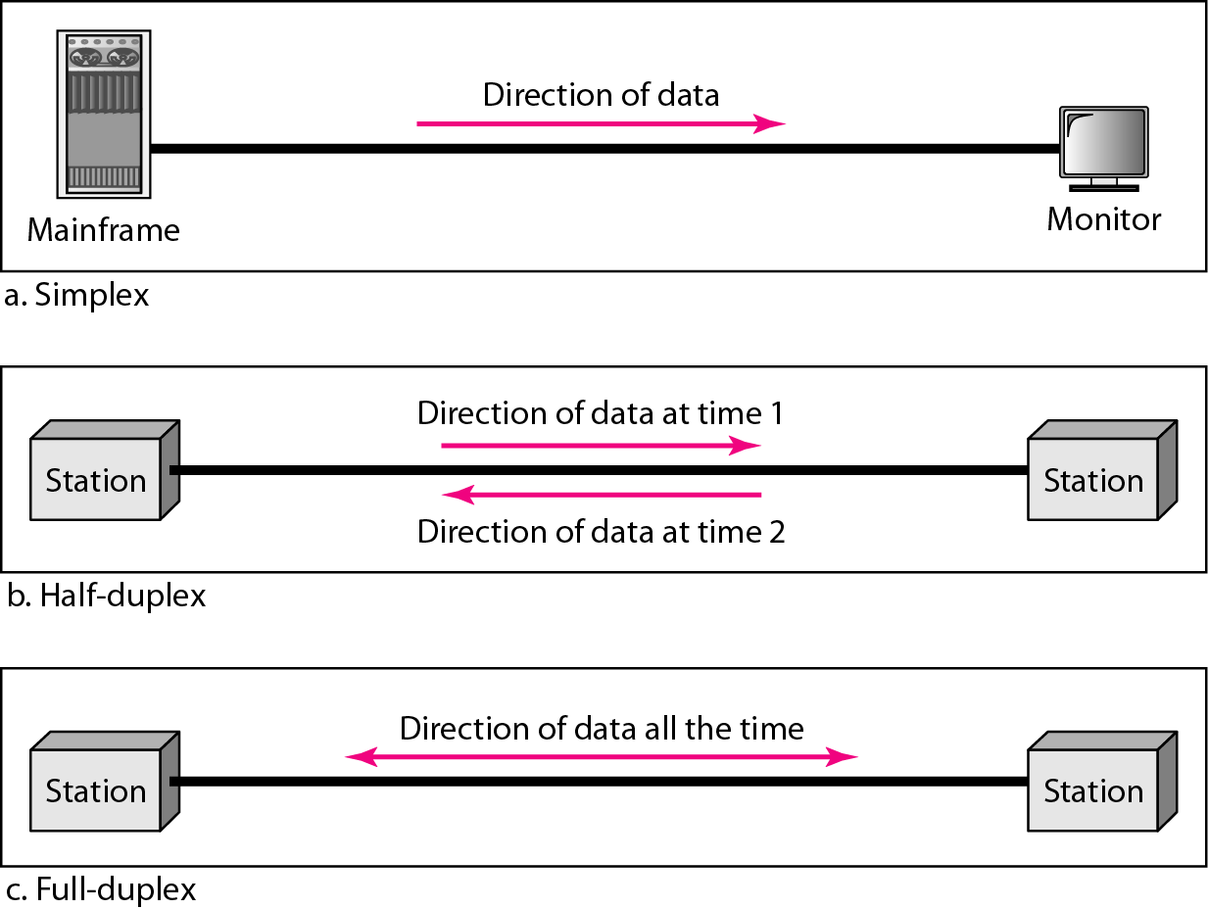

Section 2

Types of Connections:

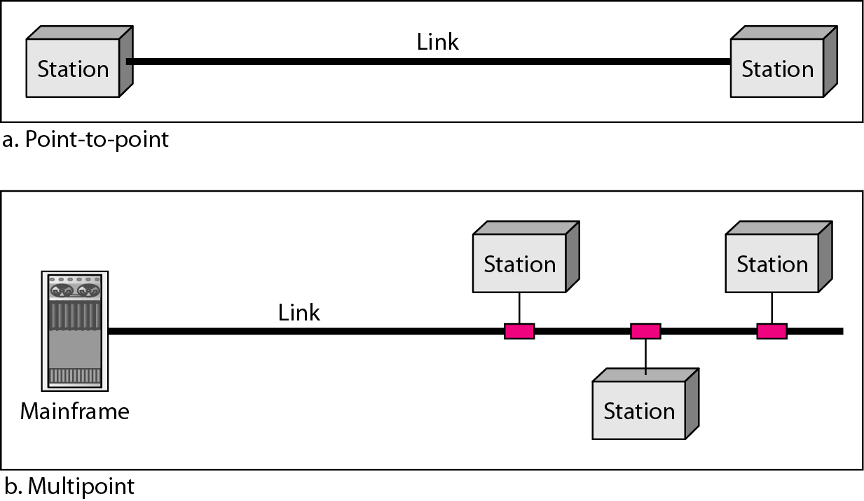

There are 4 different types of topology. Mesh Star Bus and Ring.
Mesh: Advantages:
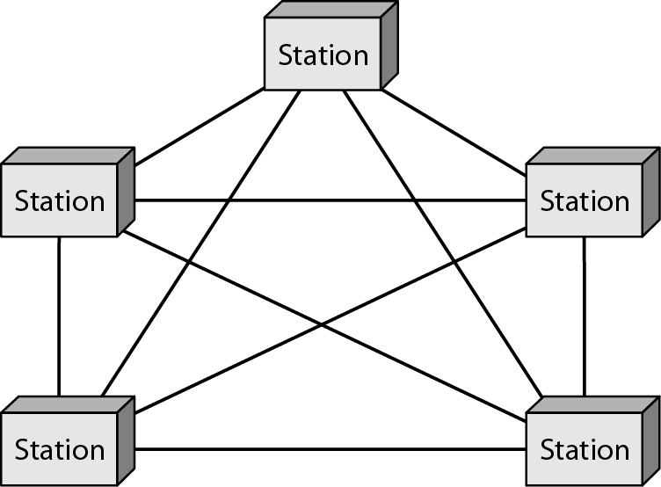
Each link carries its own data.
Its robust, so if one goes down the others stay up
Private, only intended receiver sees the content
Disadvantages:
Installation and reconfiguration are difficult
Hardware required is expensive.
Lots of cabling and I/O ports needed.

Star: Advantages:
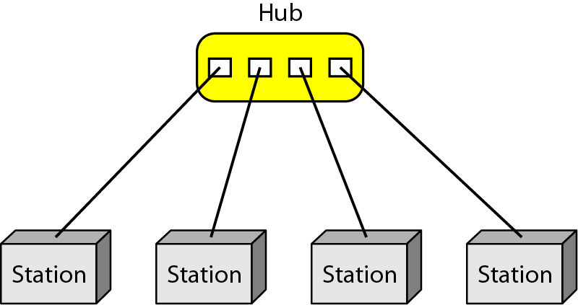
Robust
Easy fault identification and isolation
Disadvantages:
Cabling amount

Bus:
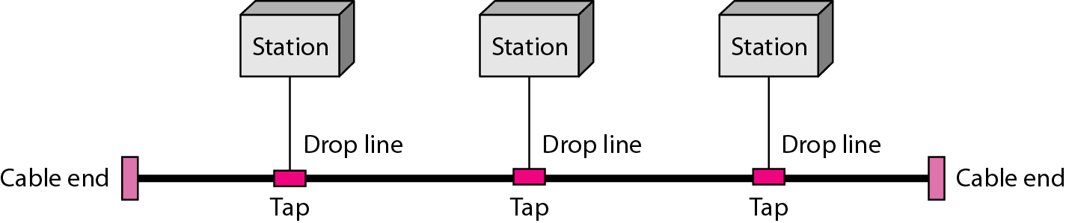Advantages:
Installation is easy
Disadvantages:
Reconfigurations and fault isolation are difficult

Ring:
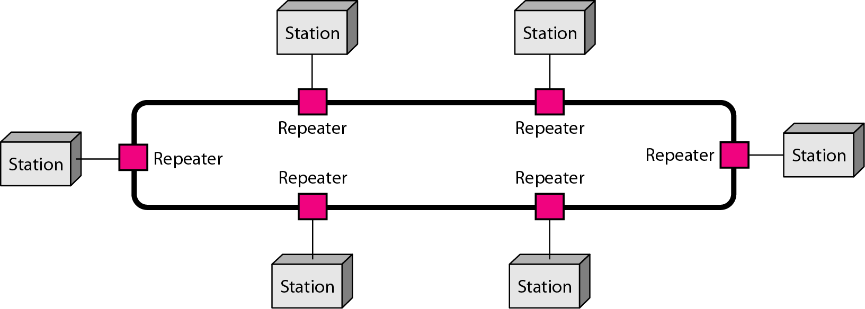Advantages:
Installation and reconfiguration are easy
Faults isolation is simplified (alarm alert for signal lack)
Dual ring or switches are used to overcome ring break

A hybrid topology is possible to have, meaning there can be two topologies in one.

There are types of network. Local area network (LAN) , Metropolitan area network (MAN), Wide area network (WAN).

Single building LAN: MAN:

WAN:

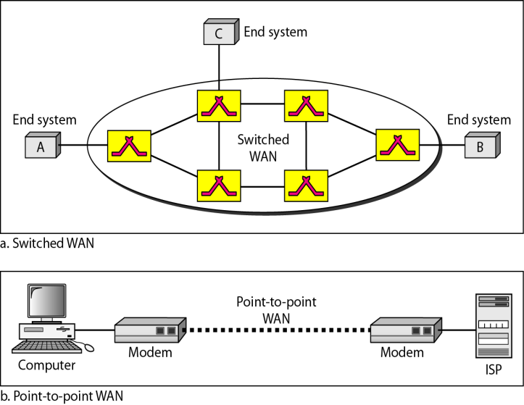

Chapter 2
Section 1 Layered Tasks

We use layers to break things down.

Section 2 OSI Model
The OSI model is designed with 7 layers. These layers help with the process of transferring data. Thee layers are as followed in descending order:
7.Application
6.Presentation
5.Session
4.Transport
3.Network
2.Data link
1.Physical

Section 3 Layers in the OSI

Physical Layer
Physical Layer is responsible for the movements of individual bits from one node to the next.
Concerned with physical characteristics of interface and media, representation of bits, data rate, synchronization of its, line configuration, physical topology, transmission mode. To transmit bis over a medium to provide mechanical and electrical specifications.

Data Link Layer
Responsible for moving frames from one node to the next. Concerned with framing,physical addressing, flow control, error control, access control. To organize bits into frames; to provide node to node delivery.

Network Layer
Responsible for the delivery of individual packets from the source host to the destination host. Concerned with logical addressing and routing. To move packets from source destination; to provide internetworking.

Transport Layer
Responsible for the delivery of a message from one process to another. Concerned with service-point addressing, segmentation and reassembly, connection control, flow control, and error control. To provide reliable process to process message delivery and error recovery.

Session Layer
Responsible for dialog control and synchronization. Concerned with dialog control and synchronization. Establishes manage and terminate sessions.

Presentation Layer
Responsible for translation encrypt and compress data.

Application
Responsible for providing services to the user. Concerned with network virtual terminal, file transfer/access/management(FTAM), mail services and directory services. To allow access to network resources.

Section 4 TCP/IP Protocol Suite
It has 4 layers, Host-to-host network, internet, transport and application. If you compare it to the OSI it could have five layers where host to host network is broken up into Physical and Data Link.

Uses a 6-byte with 2 hex digit bits for the physical address. Physical address wil change from node to node but he logical address remains the same.

Chapter 8

Section 1
A single bit error only is when only 1 bit in the data has changed. A burst error is when 2 or more bits have changed.

Section 2
In block coding we divide our message into blocks, each of k bits called dataword. We add r redundant bits to each block to make the length n = k+ r. The resulting n-b9it blocks are called codewords.

The hamming distance between two bits is the number of one digits after they are XORd together. For example 000 XOR 011 is 011 therefore the hamming distance is 2. The minimal hamming distance is the smallest value of all combinations of pairs.

Section 3
All block codes belong to a subset called linear block codes. A linear block code is a code in which the XOR of two valid codewords creates another valid codeword.

Section 4
Cyclic codes are special linear block codes with one extra propterty. If a codeword is cyclically shifted(rotated), the resut is another codeword.

Checksum
Sender Side
Take Packet Split into 4 bit sections
Add them all together
Anything that exceeds 4 bits gets wrapped around and added again
Take ones compliment and that gives ur checksum that the receiver would use
Receiver Side
Take the packet and split into 4 bit sections again
Add them all together
Instead of wrapping around you add the checksum
Then wrap around and add
Takes ones compliment of that and it should be all zeroes if no errors.

Chapter 11

V Data link layer packs bits into frames.
A frame will look like the following: 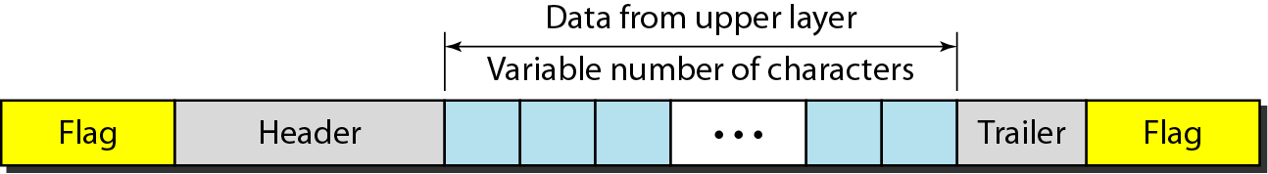
Byte stuffing is the process of adding a extra byte to where an indicated flag is or escape character. Bit stuffing is adding an extra zero after 5 consecutive 1s.
Most important of datalink is flow control and error control, these are known as data link control.
Flow control is the set of procedures used to restrict the amount of data that the sender can send before waiting for acknowledgment. Error controls is based on ARQ (automatic repeat request), which is the transmission of data.
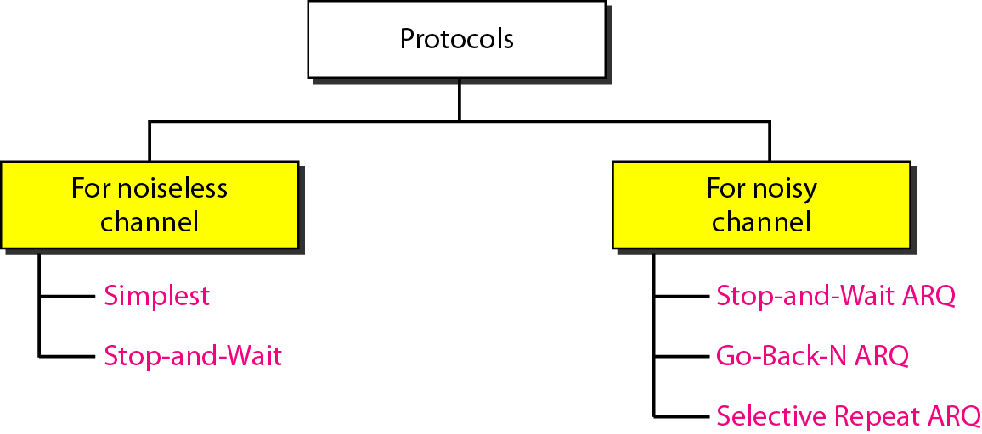
Noiseless stop and wait

Stop and wait is the same for both noiseless and a noisy channel, except in the acknowledgement it puts a sequence for the ARQ/noisy.

In the Go-Back-N Protocol, the sequence numbers are modulo 2^m -1, where m is the size of the sequence number field in bits. There is a sending window, if the sender does not receive acknowledgement for the frames that have been sent and the sender reaches the end of the sending window it will then restart at the beginning of the window.

Selective repeat arq, sends the frames one after the other, If the receiver for some reason receives a frame that is not in the sequence order it will send back a NAK which will then notify the sender that something messed up and it will restart at the lost frame.2 ^(m-1)
HDLC – High level data link controlis a bit-oriented protocol for communication over point-to-point and multipoint links.

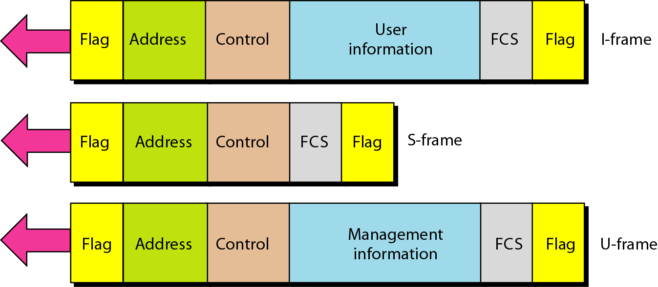
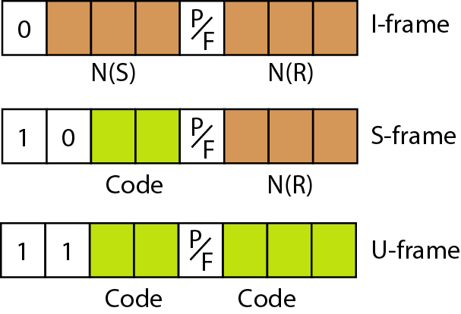

FCS – Frame control sequence, which referes to the extra checksum.

Chapter 19
Section 1
IPv4 addresses are 32 bits long.
How to determine what class an IP address falls under is given by the first couple digits. The following picture explains it:
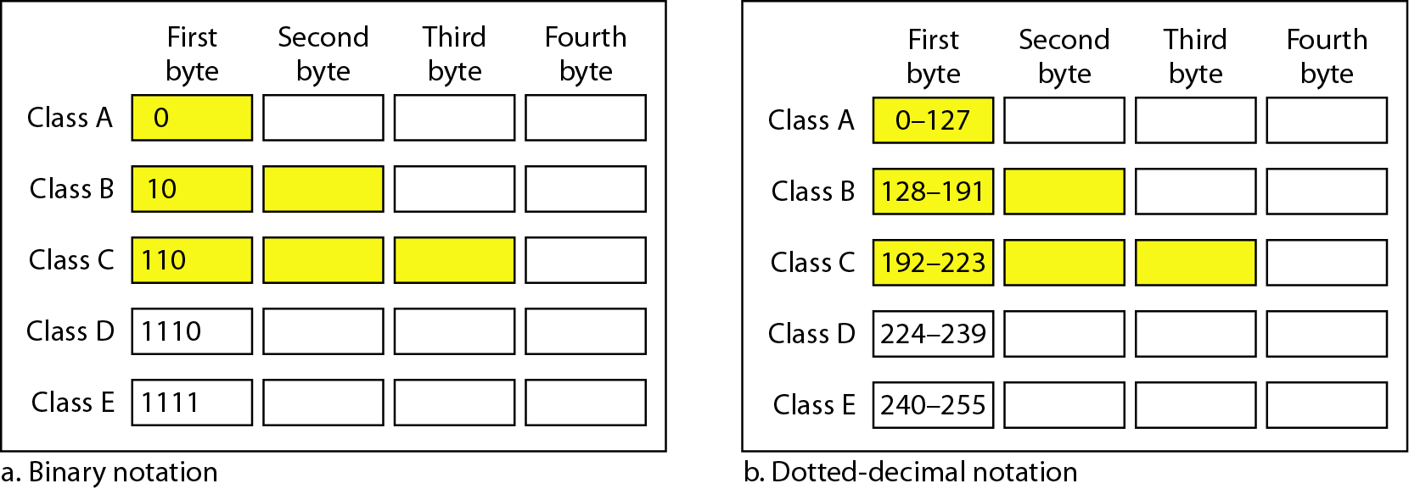

a. 00000001 00001011 00001011 11101111
b. 11000001 10000011 00011011 11111111
c. 14.23.120.8
d. 252.5.15.111
Solution
a. The first bit is 0. This is a class A address.
b. The first 2 bits are 1; the third bit is 0. This is a class C
address.
c. The first byte is 14; the class is A.
d. The first byte is 252; the class is E.

CIDR refers to which digits are part of the host ID.
In IPv4 a block of addresses can be defined as x.y.z.t/n

Chapter 20
Section 1

Switching at the network layer in the internet uses the datagram approach to packet switching
Communication at the network layer in the internet is connectionless.

Section 2
IPv4 is a delivery method for the TCP/IP protocol

Position of IPv4 in TCP/IP
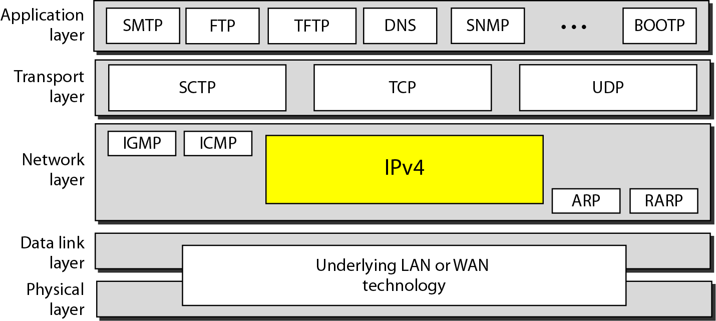

IPv4 datagram format
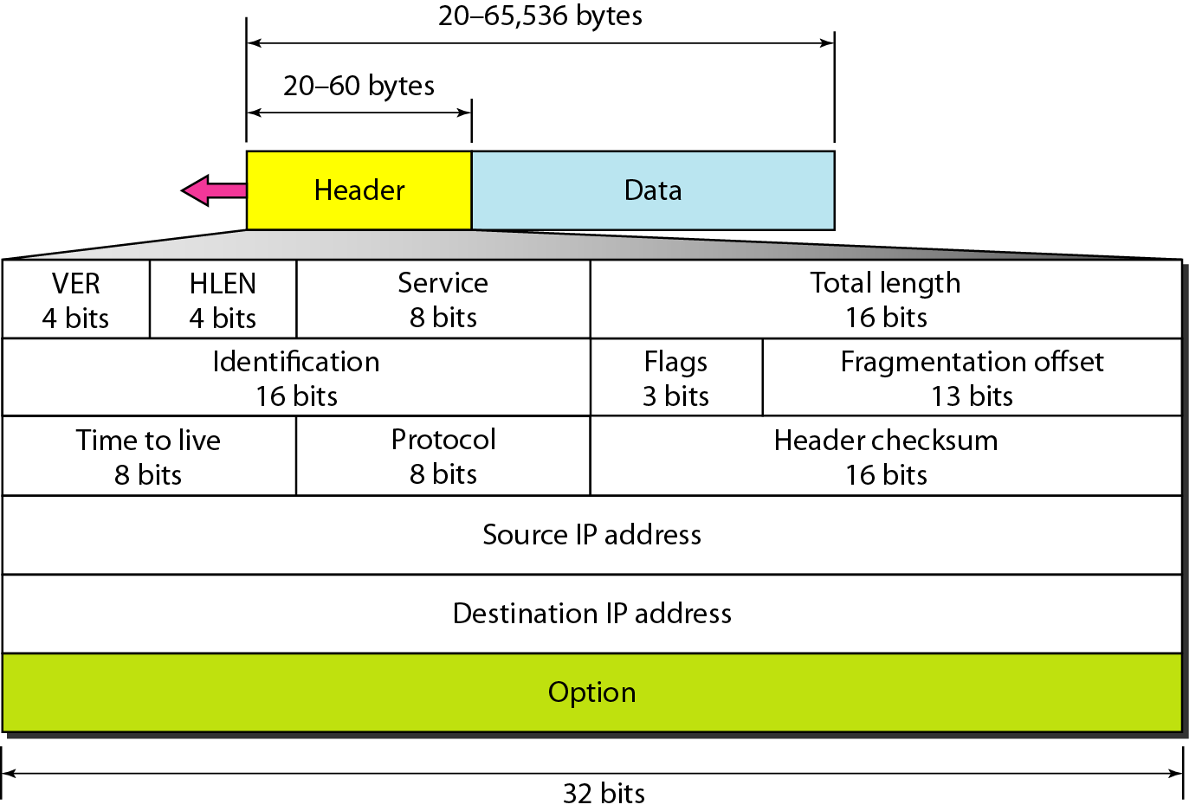

The total length field defines the total length of the datagram including the header.

Version is 4 bits either 4 or 6 if not then just drop it.
Hlen length convert the bits to decimal then multiply by 4 bits.
Service Types or Differentiated Service
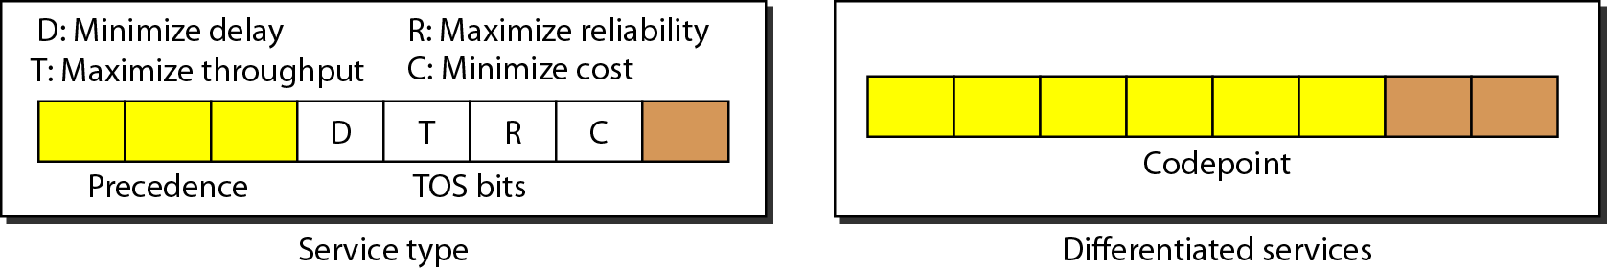
For service types , 8 bits only one can be set. If more than one it gets dropped aswell
Total length, 16 bits long.
Identification which is basically just the sequence number.
Flags is 3 bits:
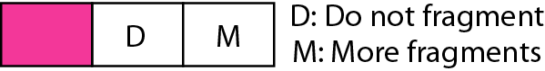

Fragmentation Offset:

TTL: Time to live: essentially just a counter which jut means it can go through however many routers. If it goes through to many it gets dropped.

Protocol :
